SimCLR is a subtype of self-supervised learning method: a constructive learning model.   
The key of SimCLR is to generate two different augmented views for each image and use them as positive pairs respectively. Then, the model is encouraged to generate similar representation vectors for this pair of images.

The workflow of SimCLR:

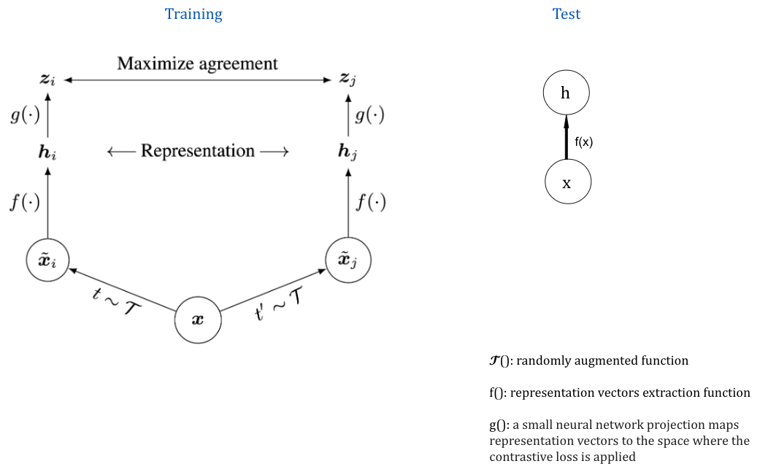

Constructive loss is defined as: